1. Put the two files git.cmd and git.jar in the server installshield-dev :

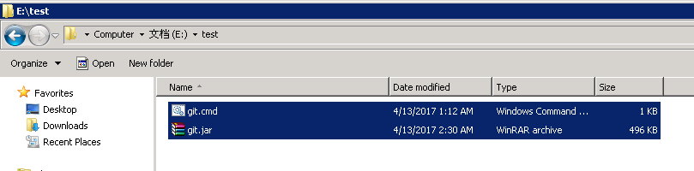

1. Double click the file git.cmd and input the version number:



1. It will send the email

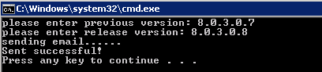

1. Check the email

